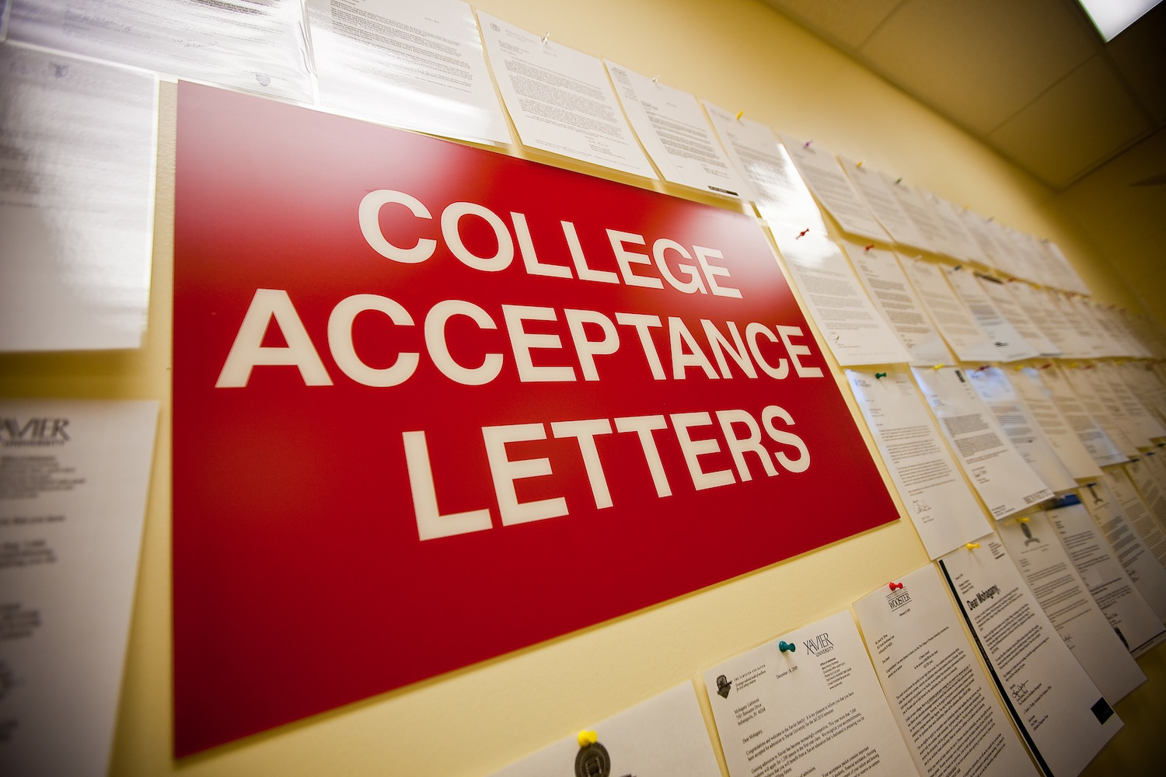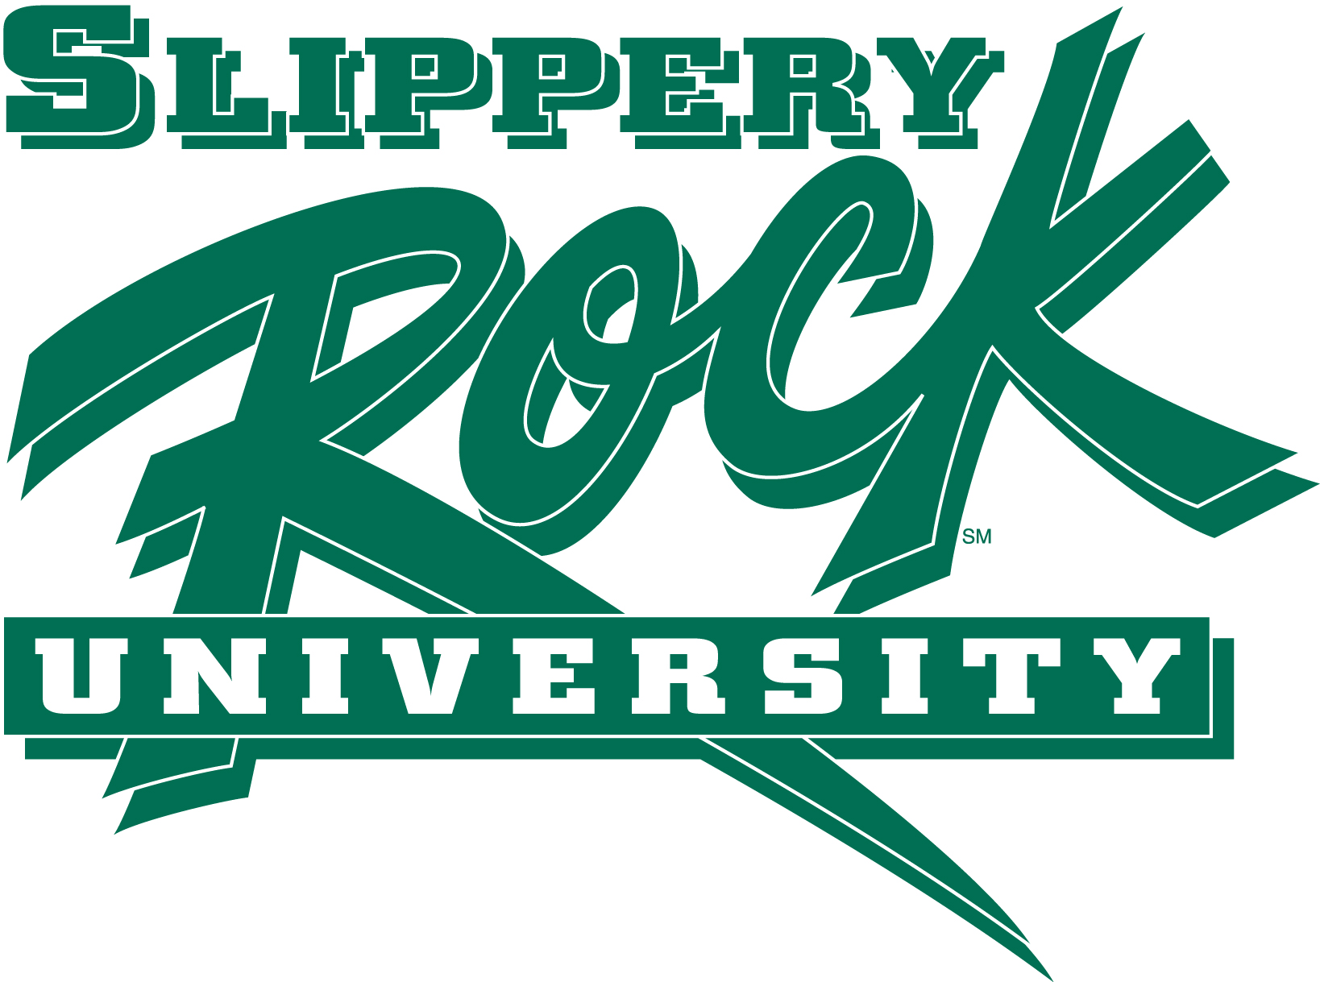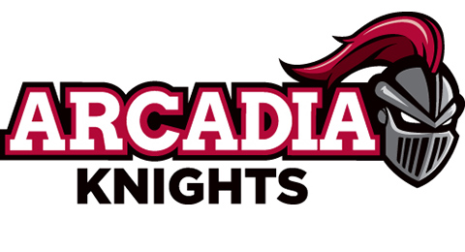

**Page 1:** Upcoming Test Dates

**Page 2:** College Profiles

**Page 3:** What To Do Once You’re Accepted  
- The Cost of College

**Page 4:** Scholarships

**Page 5:** Finding the Right College

**Page 6:** College and Financial Aid Terms and Knowledge

**Page 7:** December Checklist for Seniors

Keep studying and get ready! The ACT is almost here!

##### December ACT

12/12/15

### What’s Inside:

##### December SAT

12/5/15

Be sure to print out your admissions ticket to take with you!

#### Upcoming Test Dates

Now is the time to get those final college applications submitted! Around this time of year, it is especially important to keep deadlines in mind. You do not want to miss a deadline and not be able to go to your favorite college! Be sure to check each school’s website and write down when their application deadlines are.   
 Also keep in mind deadlines for financial aid. Some schools have separate applications or forms for financial aid, so be sure to look online to see if the schools you are applying to require a separate application. Come see the college adviser if you have any questions.

# Deck the Halls with Applications

Must register by December 28th to take the SAT on January 23rd.

##### January SAT

College Corner

the

1/23/16

December 2015

## Slippery Rock University

Located in Western PA, SRU is one of the state schools and has around 7,600 students. SRU is known for the various athletic degree options such as exercise science, athletic training, and sports management along with many other great degree options. Head out to the Rock and get a great tour of campus. Go check out their website for more info: <http://www.sru.edu>

# College Profiles

###### Take a look at the colleges below to get an idea of what each school is like.

Towson is one of the largest public universities in Maryland with almost 19,000 students. Towson is located just outside of Baltimore. There are over 60 different majors to choose from with some of the most popular being Biology, Mass Communication, Education, Nursing, and Exercise Science. For more info, go to their website: [www.towson.edu](http://www.towson.edu)

Towson University

Curtis is a highly selective music conservatory in Philadelphia, PA. There are around 200 students at Curtis. Curtis seeks to find the most talented students and they provide full-tuition scholarships to all students. This evens the financial playing field and bases admissions purely on the talent of the musician. Students participate in various ensembles and have major performances in both Philly and NYC. For more info, go to their website at [www.curtis.edu](http://www.curtis.edu)

Arcaida is a small liberal arts college near Philadelphia. There are around 2,500 students on campus and some of the most popular majors are Business, Art, and Education. However, Arcadia is best known for their extensive study abroad program with over 140 programs in 16 different countries. There is even the option of going on a “preview” to see if you would like to study in that country. Check out their website at [www.arcaida.edu](http://www.arcaida.edu)

Arcadia University

Curtis Institute of Music

###### Here is a brief overview on Financial Aid

# The Cost of College

It’s important to keep in mind that you may never know if you’re eligible for need-based aid until you apply. Much like a college application, there may be school specific deadlines for financial aid information. Most schools will only require the FAFSA, but some also will want the CSS Profile. It is important that you fill out the FAFSA as accurately as possible to avoid having to redo the application. It is also worth checking out each college’s Net Price Calculator. This will give you a rough estimate of what a financial aid package could look like. Finally, it is very important to ask questions. If you are unsure of anything call the financial aid office and they will be happy to help.

It is important to remember that even though you have been accepted to the college, you are not enrolled in the college until you pay your enrollment deposit. That deposit signifies that you will be attending that specific school.

However, you do not want to make your deposit to the first school that accepts you, unless that is your dream school. Wait for your acceptance letters from all of the schools you have applied to, and compare and contrast the different schools and what financial aid they can offer. Some schools may offer a greater amount of merit aid or scholarships than another school. By comparing and contrasting schools, it allows you to select the school that will be the best option for you to succeed.

**Why is the deposit important?**  
Most importantly, it signifies that you will be attending the school. But the deposit is important for a few other reasons.

First, it may impact housing. Some colleges have a limited number of available on campus housing, and the sooner you make your deposit, the better chance you have of securing a room on campus.

Second, it may influence academics. Some majors (nursing, engineering, etc.) only have a limited number of spots available. Depositing can secure your position within a major.

Lastly, it means that you are officially going to college!

# I’m Accepted… Now What?

Yes. Colleges may give our scholarships or grants (“gift aid”) as part of your financial aid package. These are typically associated with academic merit or community service. These forms of gift aid are funds that you will not have to pay back. In addition to the scholarships provided from the college, you are able to bring in as many outside scholarships as you receive. Outside scholarships will go towards what amount of the total cost your family is expected to pay for your education.

## Are Scholarships Included in My Financial Aid Package?

## How to Avoid Scholarship Scams

Generally, you should never have to pay to apply for a scholarship. Avoid any scholarship application that has a fee or requires your credit card information. Nobody can guarantee you will win a scholarship. If you receive an email or letter guaranteeing that you will receive a scholarship, it is most likely not a legitimate scholarship. Also, do not pay to search a database. All of the links provided above offer free searches of their databases.

There are many places that you can find scholarships. First, you can check in the Guidance office or the Guidance website under the scholarships page. You can also check on the Google Classroom Each is updated with new scholarships regularly. There are also many websites that you can search for scholarships. These are Scholarships.com, Fastweb.com, Zinch.com, CareerInfoNet.org, BigFuture.org, and USscholarshipguide.org. All of these websites have extensive listings of scholarships so be sure to take a look and see what you can qualify for.

# Scholarships: Knowing What to Look For

Scholarships can make a big difference when it comes to paying for college. Even small scholarships can add up to much larger amounts, considerably lowering how much money you will need to pay. Scholarships can help to make college significantly more affordable, giving you and your family less to worry about.

## The Importance of Scholarships

## Where to Find Scholarships

When conducting your college search, there are two main terms that you need to consider: *match* and *fit*. **Match** means finding a school that has students with similar academic standards and capabilities to you. **Fit** refers to all other aspects of the school such as social environment, physical environment, location, distance from home, academic programs, price, and many others. Both match and fit are very important to finding the perfect school for you.

**Match:**

There are a couple different ways in which you can determine if a school is a good match for you. First, you can compare your test scores to the averages. However, this cannot be your ONLY comparison. Test scores do not equate to intelligence or capability. If you are a strong student, applying to a more selective college will be a good match. You need to be careful not to *under-match*, meaning that your credentials may have been able to get you into a more selective school. Another potential way to experience the academic setting would be to sit in on a class or meet with a professor. The more ways you can experience the academics, the more likely you will be to find schools that are a good match for you.

**Fit:**

Fit is equally as important as match. It is important to balance both match and fit to find the perfect schools for you. The best way to determine if a school is a good fit for you is to actually visit the school. This will help to illustrate many of the parts that make up fit.

The ride to the college will help you understand how far away from home the college is. The drive alone may sometimes be enough to say no to a school. Being on the campus will allow you to get a feel for the environment and general layout of the campus, and receiving a tour will allow you to interact with a current student. Day visits are also encouraged as this will get you inside of the daily schedule of a college student and give an inside look at the student community. Many students describe having a certain “feeling” when they set foot on the college that is meant for them. When you find the college that is perfect for you, you will know.

**How Do I Find My Best Match and Fit?**

A good first step is to use the *College Search* tool on Big Future/College Board’s website. This filtered search allows you to input many different variables such as your SAT/ACT test scores, what type of major you are interested in, what sports you want to play, the size of the school, and many other factors. The search will then filter the results on a 0 to 100 percentage scale. The higher the percentage, the more that school meets the criteria you are looking for. Even if you find a school that is a 100% match, it is still highly recommended that you actually visit the campus. How a college appears in reality may be vastly different that what it appears to be on paper. Do not be afraid to ask for help from parents, friends in college, teachers, or your college adviser. But remember, it ultimately is your decision, and you must decide to go to a college that you want to be at and where you know you will succeed.

# How Do I Find the Right College for Me?

**Talking the Talk:**

*Terms to know and knowledge to have about college admissions*

*and financial aid*

**- FSA ID** – A username and password that you will use to login to the FAFSA website as well as sign your FAFSA. Both you and your parents will need to have an FSA ID.

**- Need-Blind Review** – Your financial need will not play a role in determining whether you will be accepted into a college.

**- Net Price** – What the remaining cost of paying for college is after factoring out the EFC and any grants or scholarships. Sometimes known as the “*Out of Pocket Costs*.”

**- Net Price Calculator** – Tool on all college websites to provide you with an estimated financial aid package based on your family’s information.

**- Regular Decision** – The standard admissions deadline.

**- Rolling Admission** – Applications will be reviewed as they are received; typically a faster review process. College will continue to accept students until all open spots are filled.

**- Subsidized Loan** – Government pays interest on the loan while the student is in school.

**- Superscore** – If you take the SAT/ACT multiple times, the admissions office will only see your best scores from each section.

**- Test-Optional** – A college may not require SAT/ACT scores for admission; however, you may need test scores to be eligible for merit aid.

**- Unsubsidized Loan** – Interest is added to the balance of the loan while you are in college; interest is not paid for you on this loan.

- **Early Action** **–** A non-binding application that typically has a deadline in November or December. Occurs before regular or rolling decision. If accepted, you are not required to attend.

**- Early Decision** – Apply early decision if you are absolutely sure that a college is your #1 choice. If you are accepted, you are required to attend that school.

**- Expected Family Contribution (EFC)** – How much money your family is expected to pay towards your college education.

**- FAFSA** (*Free Application for Federal Student Aid*) – Indicates how much Federal financial aid a family is eligible for; also makes student and parents eligible to receive Federal loans.

**- For Profit College** – Schools are operated and owned by private businesses that operate them to gain profit. Prices are usually very high with minimal financial aid.

**- Grant/Scholarship** – A form of financial aid that does not require the student to pay back the amount of money.

**- Interest Rate** – A percentage of a loan, in addition to the total amount of the loan, that you pay to a lender in order to borrow money.

**- Merit Aid** – Financial aid award given based on high school GPA, SAT/ACT scores, and sometimes leadership/community involvement.

**- Need Based Aid** – Financial aid given based on how much of the total cost of college is leftover after factoring out the EFC; may come in the form of grants, scholarships, and/or loans.



* Finish and submit college applications. At the very latest, you should have submitted your applications before Christmas break.
* Create a spreadsheet to keep track of the schools you have applied to, their deadlines, financial information, or any other important information you need to keep track of
* It is also important to keep visiting schools. If you are on the fence about a school, go take a look around.
* Stay up to date on what scholarships are available and be working on any that you qualify for and are able to do.
* Be sure to the Guidance Office if you have been accepted to a college
* If needed, ask teachers for recommendation letters. Be sure to ask in advance of any deadlines.
* Do not be afraid to ask questions of colleges. Call the Admissions or Financial Aid Offices with any questions you may have.
* Come to Guidance or see your College Adviser if you have any questions or need assistance

Checklist for Seniors

December 2015

The College corner